## Prelim Pages

Version Control /Approval etc

## Introduction

The ability to modify column structures enables quick updates when the need arises. As a system undergoes changes or the scripts need to expand their scope, so does the need to modify the masters’ layout. This tool is designed to meet this need and perform the actions of modifying the structure though interaction with a user form.

## User Interface

The restructure tool interface is a very simple form with a list of the column names and a few buttons to act on those names. The underlying code ensures that you cannot move a column outside the list boundaries and ensures you can cancel at any time to prevent an error from transferring to the master.

Users need only have a plan in mind when performing this action, and through the interface:

* Select the column in the list,
* Click a button for your desired action,
* Answer any dialogs the pop up, and
* Repeat the selection/button actions until you have completed the restructure.

# 

Figure

Once completed and the user is satisfied the restructure is correct, click OK to save the changes or click Cancel to prevent that and return to the unchanged master. Perform any maintenance on the test scripts to match changes.

The colour picker only appears when inserting a new column. Simply pick the colour according to the colour scheme that is documented.

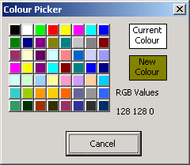

Figure

## Colour Schema

Colours are used to help quickly identify the purpose of the fields in the spreadsheet. Colours are not transferred into the test tool. Keep this table updated as the needs are modified.

|  |  |  |  |
| --- | --- | --- | --- |
| **Colour** | | | **Purpose** |
|  |  |  | Data from Target System |
|  |  |  | Mandatory data – all cells in column filled |
|  |  |  | Generated Data – do not force after creation |
|  |  |  | Critical Columns for Spreadsheet and/or test tool scripts. Do not Delete |

...oooOOOooo...